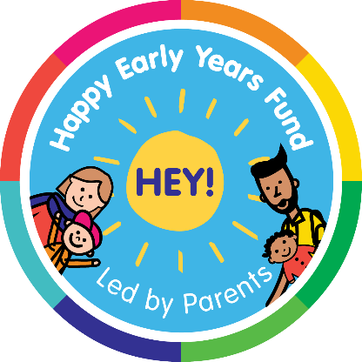

It is important to
read the HEY! Fund guidance notes before completing this form.

1. Parent* applying (*adult carer for example, parent, foster parent, grandparent)
Name:

Email:
Phone:
Address:

Are you a parent* of 0–3-year-old? Yes ☐ No ☐
Are you happy to be on a HEY! Fund WhatsApp group if successful? Yes ☐ No ☐

2. Your initiative
What is your idea/initiative name: (Please note you can change the name at a later stage if you wish)

Where will your initiative take place? (Please provide a full address and postcode)

Are you being supported by a community group or organisation? Yes ☐ No ☐
If yes, please provide details of the community group or organisation?

3. How does your initiative match our themes?
Please click/tick the themes that your initiative will achieve with a brief explanation of how.
(You do not have to match to all three outcomes it is better to match one strongly)
☐ | Eat well and be healthy
☐ | Talk and communicate well
☐ | Be confident, friendly and understand their emotions

If you have any questions as you complete your application, ring the Community Engagement Manager Shummel Uddin on 07986671806 or email shummel.uddin@betterstartbradford.org.uk.

4. Your idea
Tell us about the initiative you wish to deliver for expectant parents or families with 0-3s?
(Please keep your information simple and to the point. We need enough detail to understand what you’re planning to do and why you want to do this. Feel free to detail this in a separate sheet)

If applicable, what day(s) of the week will your initiative take place?
How many children aged 0-3 will be involved?
If applicable, how many sessions will the initiative run over?
Will you be targeting a particular demographic? for example mums, dads, grandparents, a particular community
What do you plan to do with all the resources you have bought at the end your initiative?

5. Costs
Please break down your costs for example resources (play/art equipment etc), volunteer expenses, venue, interpreters etc. The guidance notes have more examples of costs.

List each item | Cost
Total
6. About your development
By delivering this idea/initiative, you will get opportunities to develop many skills that will be recognised throughout delivery and perhaps lead to greater things for you personally.

Will you be interested in accessing training and support for your own personal development? Yes ☐ No ☐

Signature: ___________________________________________________

Name: ________________________________ Date: ________________

Return your completed form to:
Happy Early Years Fund - Better Start Bradford, Mayfield Centre, Broadway Avenue, Bradford, BD5 9NP
Or email your application to Shummel.uddin@betterstartbradford.org.uk

